**PROJECT DESIGN PHASE-II**

|  |  |
| --- | --- |
| Date | 08 November 2023 |
| Team ID | 9FCEEE4EFB15B1C90EB4811A3F79BD60 |
| Project Name | Content Marketing Plan template Based on Hubspot |

**Determine the Requirements**

**Customer Journey Maps**

Creating customer journey maps for Akshaya Fashions involves visualizing the entire customer experience, from discovering the brand online to making a purchase and post-purchase engagement. These maps provide insights into customer needs, behaviors, and pain points, enabling the brand to tailor its marketing and service to enhance the overall customer journey.

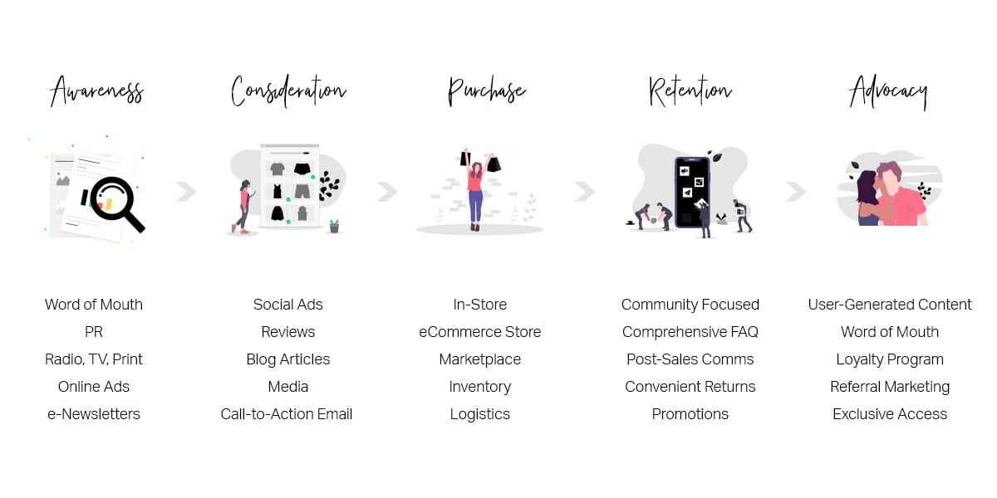

**Requirement Analysis**

**Solution Requirements (Functional & Non-functional)**

**Functional Requirements:**

Following are the functional requirements of the proposed solution.

|  |  |  |
| --- | --- | --- |
| **FR NO** | **Functional Reauirement**  **(Epic)** | **Sub Requirement (Story/ Suub-Task)** |
| FR- 1 | User Registration | Registration through blog  Registration through Gmail  Registration through facebook |
| FR-2 | User Confirmation | Confirmation via Email  Confirmation via OTP  Confirmation via call  Confirmation via message |

**Non-Functional Requirements:**

Following are the non-functional requirements of the proposed solution.

|  |  |  |
| --- | --- | --- |
| **FR NO** | **Non-Functional Requirements** | **Description** |
| NFR- 1 | **Usability** | This brand is a brand of trqaditional yet trendy clothing, offers valuable usability. Its garments are suitable for everyday wear, special occassions, cultural celebrations, office attire and even as thoughtful gifts. Customers appreciate the brand’s flexibility in styling, marketing it a valuable addition to their fashion choices. |
| NFR-2 | **Security** | The Brand places a strong emphasis on brand security. The brand protects its intellectual property, ensures consistent product quality and maintains an ethical supply chain. Customer data is secured and trust is fostered through transparency and exceptional customer service. Legal protections are enforces, reinforcing the brand’s security in competitive fashion industry. |
| NFR-3 | **Reliability** | This brand exemplifies reliability in trendy yet traditional clothing. Customers trust the brand for consistent, high-quality and etthically produced attire. Whether it’s a classic ethnic outfit or a contemporaty ensemble, Akshaya Fashions ensures punctual deliveries and responsive cusstomer service, upholding its reputation as a dependable and reputable brand. |
| NFR-4 | **Performance** | This brand excels in performance with a track record of delivering high-quality trendy yet traditional attire. The brand effectively meets customer expectations, adapts to market trends and maintains an excellent reputition. Its strong online presence, ethical practices and exceptional customer service contribute to its outstanding performance in the fashion industry. |
| NFR-5 | **Availability** | Akshaya Fashions ensures widespread availability, both in physical retail outlets and online platforms. This brand, specializing in trendy yet traditional clothing, offers convenient access to its diverse customer base. It maintains consistent product supply and global accessibility, allowing customers to easily find and purchase their preferred attire. |
| NFR-6 | **Scalability** | Akshaya fashions demonstrates exceptional scalability as a brand specializing trendy yet traditional clothing. With the ability to expand production, reach new markets and diversity product lines, it adapts effectively to growing demand. This agility ensures its continued success and relevance in the dynamic and ever-evolving fashion industry. |

**Technical Architecture**

The technical architecture for Akshaya Fashions involves a robust e-commerce platform, secure payment gateways, a responsive and user-friendly website, database management for inventory and customer data, cloud hosting for scalability, and integration with analytics tools for data-driven decision-making, ensuring a seamless and secure online shopping experience.

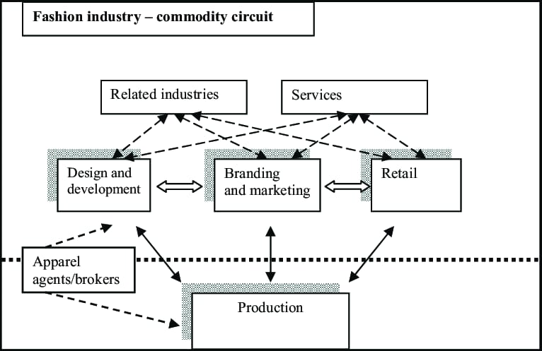

**Open Source Framework**

Using Facebook, Instagram, a blog, and email as a framework for Akshaya Fashions provides a holistic approach to digital marketing:

|  |  |  |
| --- | --- | --- |
| **S.No** | **Type** | **Description** |
| **1** | **Facebook & Instagram** | These platforms can be used for visually engaging content, showcasing products, and running targeted ad campaigns to reach a wider audience. |
| **2** | **Blog** | The brand's blog can serve as a content hub for informative articles, fashion tips, and behind-the-scenes stories, enhancing brand credibility. |
| **3** | **Email Marketing** | Email campaigns can nurture leads, inform subscribers about promotions and new collections, and engage with customers, fostering brand loyalty. |

**Third party APIs**

Akshaya Fashions can benefit from integrating various third-party APIs to enhance its services and user experience. Some potential third-party APIs to consider include:

|  |  |  |
| --- | --- | --- |
| **S.No** | **Content** | **Description** |
| **1** | **Payment Gateways** | Integration with payment providers like PayPal, Stripe, or Square for secure and convenient online transactions. |
| **2** | **Shipping & Logistics** | APIs from carriers like FedEx, UPS, or USPS to provide real-time shipping quotes, tracking, and delivery options. |
| **3** | **Social Media Integration** | APIs from Facebook, Instagram, and other social platforms for easy sharing and cross-promotion. |
| **4** | **Analytics & Data Tools** | Integration with Google Analytics or other analytics services for tracking website and marketing performance. |
| **5** | **Email Marketing** | Third-party email marketing services like Mailchimp or SendGrid for managing and automating email campaigns. |
| **6** | **Review & Feedback** | Integration with platforms like Trustpilot or Yotpo to collect and display customer reviews. |
| **7** | **Custommer Support** | APIs from customer support tools like Zendesk for managing customer inquiries and support requests. |
| **8** | **Inventory Management** | Integration with inventory management systems for real-time inventory updates and order management. |
| **9** | **Product Recommendations** | Utilize recommendation engines like Barilliance to offer personalized product suggestions to customers. |
| **10** | **Search & SEO** | APIs like Algolia for enhanced on-site search and SEO optimization. |

**Cloud Deployment**

Deploying Akshaya Fashions in the cloud involves several steps:

|  |  |  |
| --- | --- | --- |
| **S.No** | **Steps** | **Description** |
| **1** | **Choose a Cloud Provider** | Select a cloud service provider such as Amazon Web Services (AWS), Microsoft Azure, or Google Cloud Platform (GCP) based on your specific requirements and budget. |
| **2** | **Set up Cloud Infrastructure** | Create virtual servers (instances) to host the brand's website and e-commerce platform. Configure them with the required resources. |
| **3** | **Database Deployment** | Choose a cloud-based database service or set up a database server to store customer data, product information, and inventory records. |
| **4** | **Data Migration** | Migrate existing website content, customer data, and product details to the cloud-based infrastructure. |
| **5** | **Security Measures** | Implement security measures like firewalls, encryption, and access controls to protect customer data and transactions. |
| **6** | **Scalability & Load Balancing** | Configure autoscaling to handle traffic spikes, and use load balancers to distribute incoming requests evenly. |
| **7** | **Content Delivery** | Set up a Content Delivery Network (CDN) to optimize content delivery and improve website loading times. |
| **8** | **Backup & Recovery** | Establish automated backup and disaster recovery solutions to ensure data integrity. |
| **9** | **Testing & Monitorinng** | Conduct rigorous testing to ensure that the website operates seamlessly in the cloud. Implement monitoring tools to track performance and security. |
| **10** | **Domain Configuration** | Update DNS records to point to the new cloud-based servers. |
| **11** | **Launch** | Once all configurations are in place and tested, launch the brand's website on the cloud. |
| **12** | **Continuous Optimization** | Regularly monitor performance, security, and costs, and make adjustments as necessary to optimize the cloud deployment. |